**Exp-5**

Write a shell script and C program to performthe following string operations:  
**a)** To extract a substring from a given string.

{Extract list of N characters of string. Extract specific character onwards. Extract characters between given range. Extract characters by give range in negative}

Compare the running time of shell script and C program using the time command.

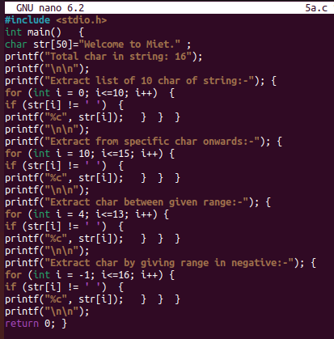

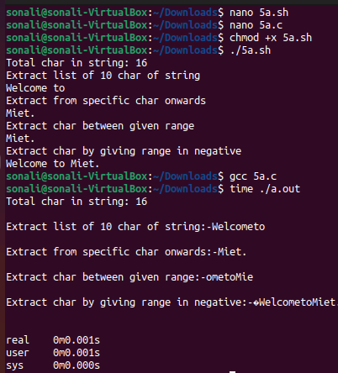

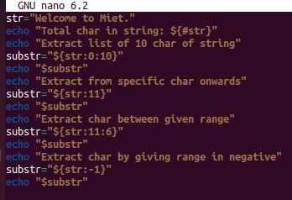



**b)**To find the length of a given string.  
Compare the running time of shell script and C program using the time command.

